

**Critical Design Review Report**

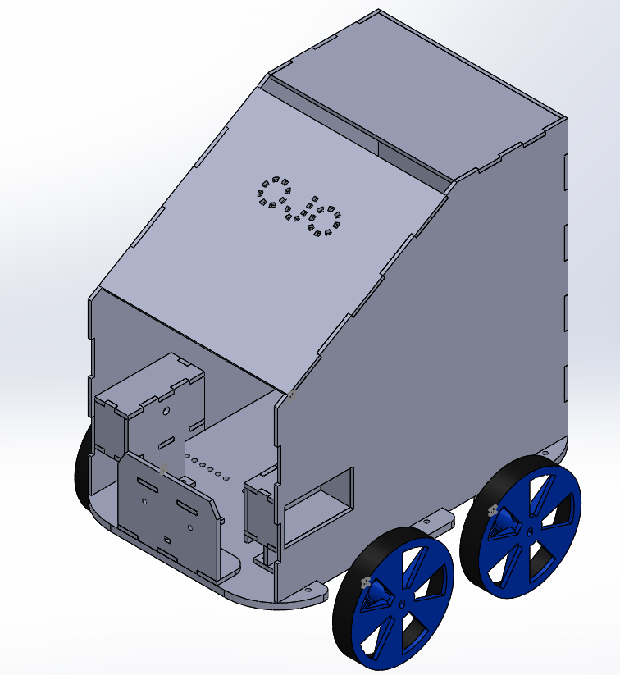

**Abdullah Aslam**

**Anar Abdullayev**

**Bulut Ulukapı**

**Syed Saad Saif**

**Umut Can Serçe**

[**Introduction**](#_zccnkye1d444) **3**

[**Overall System Description**](#_olyw88njanpm) **3**

[System and Subsystem Level](#_yvofp53divr3) 3

[Main Controller](#_cjqbnrs8ncqm) 5

[Control library](#_uq9u25nxbv3m) 5

[Flags](#_1wnw2l9h5i6l) 5

[Sensor library](#_y7ge0e1opgpr) 6

[Direction sensor](#_jak69754pri0) 6

[Front, side and back distance sensors.](#_1k7zcwy6wlah) 6

[Motors and drivers](#_wx618hh4kty) 6

[External leave command](#_3elvx2jb7d0c) 6

[Power system](#_uray9ewcgcdp) 6

[Image processing](#_bdqmi8ne642l) 7

[Visibility Marker Detection](#_jg8z9riijp4x) 7

[Leaving Signal](#_vo5zyofah5z) 10

[All Control and Data Signals with Their Feedback Paths](#_3227c0ns3qdn) 10

[**Technical Specifications**](#_70atlt40nm81) **11**

[Overall System Specifications](#_yrnyi6fwhwwi) 11

[Module Specifications](#_u2jjmdsmes6k) 11

[**Design Modifications**](#_8ul3x1gvqosu) **13**

[Design Changes](#_lsrx9ghj9efe) 13

[Four-wheel and four motors drive system](#_kihx5fqllxny) 13

[Solar panel inside the box](#_e9gyxawztjna) 13

[Chassis](#_610cjiv1fsvt) 13

[Updated Standards](#_t6jp4o4cs6qm) 13

[IR signal protocol change](#_rfw4tn5qehei) 14

[Number of Visibility Marker LED](#_ec1ahgvcdj66) 14

[Restrictions placed on the rectangle](#_4kmaca4hevtw) 14

[Reasons for change in standards](#_h2uj2txcrgcn) 14

[IR signal protocol change](#_3mrdrzo8zqgu) 14

[Number of Visibility Marker LED](#_72xkaolzqrg8) 15

[Restrictions placed on the rectangle](#_fafosiz9jvuf) 15

[**Compatibility Analysis of Sub-Blocks**](#_hvuh6avf5qd7) **15**

[Sensor Signal Interfaces](#_nld0yyxdmfgt) 15

[Distance and Direction Sensors](#_lxvdonwa20lz) 15

[Raspberry Pi and Camera Distance and Direction](#_29ywpkvoqeql) 15

[IR Distance and Direction Sensor Interface with Arduino](#_k1gxvhic3b3y) 15

[Standalone IR Direction Sensor](#_t7hajnt0khp1) 16

[Standalone Ultrasonic Distance Sensor](#_7310r1p51ape) 16

[Solar Panel Laser Identification Sensors](#_kyxwg1sg1gd7) 16

[Actuator Signal Interfaces](#_wfrdygsy9tzl) 16

[Robot Motors](#_955s02ovg62x) 16

[Sensor Signal Interfaces Diagram](#_4kuetm8j642z) 17

[**Compliance with Requirements**](#_ybsxjbpc72on) **17**

[Design Requirements](#_9djm7vffysps) 17

[Design Decisions According to the Requirements](#_b7m6uar6w0vm) 18

[Possible Error Sources](#_r2fqeeoqhk9) 19

[**Test Procedures and Assessments of Test Results**](#_wbqs3eja1m4x) **19**

[Image Processing](#_gxoej92qm870) 19

[Color Detection (red and green color)](#_wv1athkbdqzr) 19

[Green Rectangle Detection](#_lee4hgaybap) 20

[Accuracy and precision of distance, direction and orientation.](#_5xpiygo2kvdy) 20

[Distance Sensors](#_fkmgans1hpsi) 21

[IR Distance Sensor](#_2hnzqy62nzwt) 21

[Ultrasonic Distance Sensor](#_qo1fa9phhcd4) 21

[Solar Panel](#_wkohelenwg4o) 23

[Robot Speed](#_85h6ei3p5xhd) 23

[Turning](#_xegpl465rucm) 24

[Leaving](#_tdvaef209dvg) 25

[Following](#_xg1q2l9flkwj) 25

[Power Delivery](#_6ym5dm7qi1jv) 26

[**Resource Management**](#_qex2y1hplw92) **27**

[Budget Analysis](#_voa9scehce3h) 27

[Power Distribution and Management](#_mf1nxr1ubead) 27

[CPU Resource management](#_3d9kkkq9j6al) 28

[Memory](#_rgv4fzdvvr8r) 28

[Gantt Chart](#_y4vmrv4aumnb) 29

[**Conclusion**](#_1qyqgaqa6uzn) **29**

[**Appendix**](#_auf2q7loq2nd) **30**

# 

# Introduction

As of now, most of the critical subsystems of the project have been implemented. This report, is a critical report, contains the detailed description of the overall system and the subsystem. For each subsystem, technical specification details are provided as well as the tests conducted with the results are provided. This report also contains the modifications made for the project. Furthermore, compatibility between the subsystems, robustness of the robot, power analysis and budget analysis are also the part of the robot.

# Overall System Description

## System and Subsystem Level

Behaviours of the vehicle are described in different levels. Figure 1 below illustrates the most general functional flow chart of the robot.

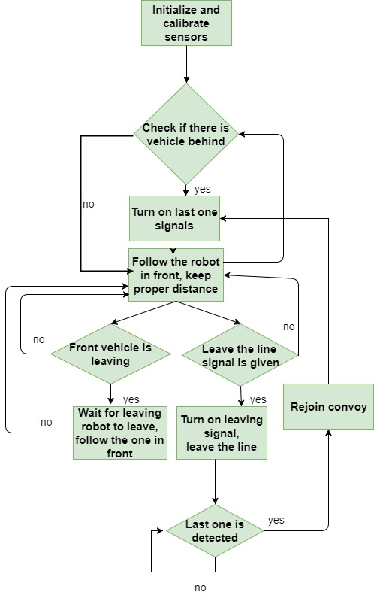

**Figure 1:** Simplified block diagram

To achieve the functions mentioned in Figure 1, different sensors, actuators and other parts are required to be mounted on the chassis of the robot. Figure 2 describes the relationship between the main parts.

.

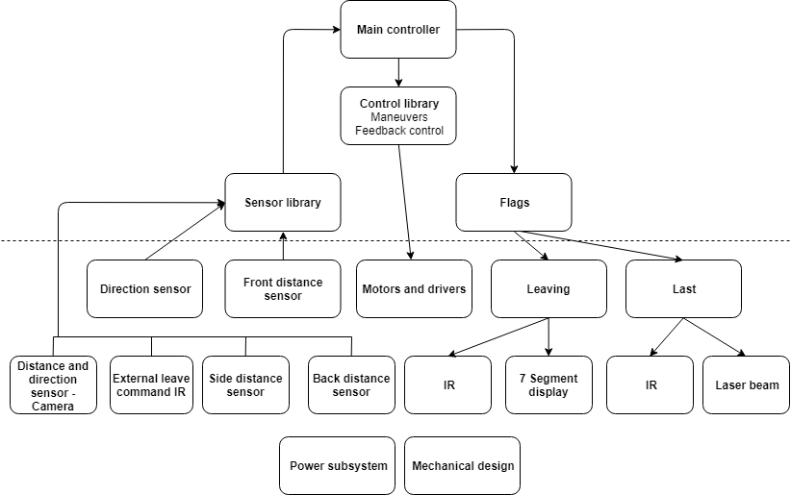

**Figure 2:** Overall Description of the system

Note that, parts below dotted line are physical and the rest are implemented in software. Main controller takes all the information from the sensor library and choose the proper maneuvers of the robot and control the flags accordingly. Explicit behaviours of the main controller is described in Figure 3.

### Main Controller

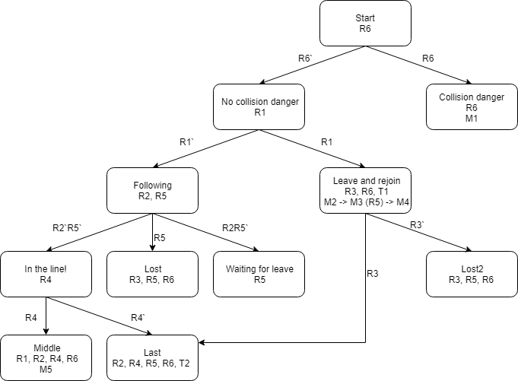

**Figure 3:** States of the main controller

The information mentioned in the states of the main controller is coded and explained in Table 1.

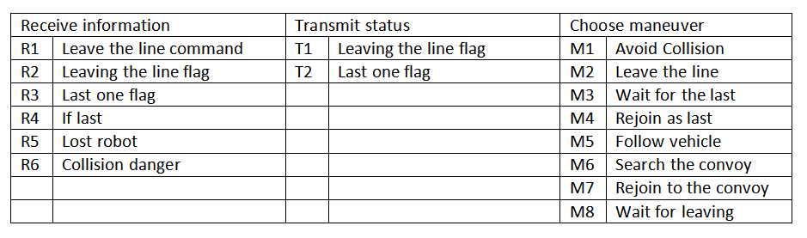

**Table 1:** Explanation of the codes

### Control library

Control library holds the codes of the maneurs and feedback control. Output of this library drives the motors.

### Flags

The vehicle has two kind of flags and controlled by the main controller. Both leaving and last one flags implemented in two ways. The first leaving flag is special signal defined in the standard and be transmitted by the power IR LED. This LED will be driven by the constant current circuit using LM317 regulator. The second leaving flag is displaying figure 8 on a seven segment display placed on the back of the robot. The first last one signal will also be transmitted by the IR LED. The second last one signal is laser beam. Two lasers will be placed on the sides of the robot and will be detected by the solar panels.

### Sensor library

Sensor library is used to combine information delivered by different sensors. Since all signals should be given in two different manner as a requirement of a project they will also be received by different sensors. Distance information can be obtained from camera and IR distance sensor. If both sensors return proper information sensor library will take average according to the coefficient of the trust value of the sensors. If only one sensor is operating sensor library will return that value.

### Direction sensor

Direction sensor consisted of two IR receiver LEDs placed in front of the robot. According to the light intensity voltage level on the analog pin of the arduino will be changed and from the voltage difference direction will be deduced. There will also be another infrared sensor to detect modulated IR signal.

### Front, side and back distance sensors.

In the front of the robot IR distance sensor will be used. The information delivered by this sensor is important for the following the robot with proper distance. Ultrasonic distance sensor will be used in the back of the robot for testing if there is any vehicle behind or not. This information will inform the main controller if the vehicle is last or not. In the sides of the robot also ultrasonic sensors will be used. To prevent crashes main controller will use distance information delivered from all these sensors.

### Motors and drivers

The vehicle has four motors. Two mosfets are used to drive the motors. To turn the vehicle differential drive principle is applied. Both motors on the left or right are driven by the same signal.

### External leave command

External leave the line command will be given by the generic remote control and will be determined by the IR detector. Received signal will be processed by the Arduino.

### Power system

To power up the device 12V lead acid battery is used. Also to achieve 5V voltage level which is required for powering Arduino, Raspberry Pi and other sensor DC-DC converter is used.

### Image processing

This module is responsible for the detection of the visibility marker and determination of the leaving signal. Moreover, it is also responsible for measuring the distance, determining the direction and orientation of the front robot with respect to our robot. The output of this module, which is the relative distance, direction angle and orientation angle of the front robot with our robot is send to sensor library.

This module processes the information captured by the camera, of our robot, in real time. By applying some algorithms on cameras feed we can achieve our goals. We are using OpenCV library on python platform for coding and later the code will be implemented on Raspberry Pi 3.

#### Visibility Marker Detection

For the visibility marker detection, the aim is to first filter the green color out from the cameras feed and then apply the shape detection algorithm for rectangle detection. For green color detection, the cameras feed, which is in RGB, is converted to HSV. Then it is blurred to reduce noise. The upper and lower bound for green color is defined and a mask is created, which is applied on the blurred video. The purpose of the mask is to extract only the green color in the video. Let’s call the result obtained after green color detection as ‘result’. For rectangle detection, canny edge detection is applied on the result and then contours in the result are found. Then the shape detection code from OpenCV library is applied. Which determines the vertices of the shape and approximates the shape as rectangle if four vertices are found. After the green rectangle is detected, only the rectangle that satisfies the visibility marker specifications is considered. Then the corners of the rectangle are found, and using them, height, width, right edge height and left edge height and center of mass of the rectangle (visibility marker) are determined. This information is then used to calculate the relative distance, direction and orientation information of the front robot (visibility marker). Figure 4 shows the output feed of the camera and end result screen after our code is applied.

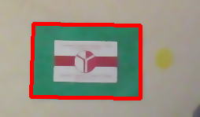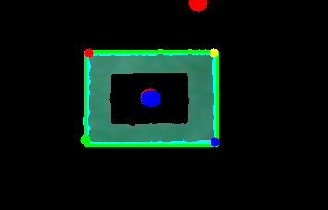

**Figure 4:** Output of camera (left), result after applying algorithm(right)

There are two critical cases that are considered.

**Case 1:** Plane containing camera is parallel with the plane containing visibility marker.

In this case the visibility marker looks like a rectangle in 2D projection (on the screen). It might be at an angle from the camera and this angle is defined as direction angle (α). If the visibility marker is directly in front of the robot then α is zero.

**Case 2:** Plane containing camera is **not** parallel with the plane containing visibility marker.

This implies that the front robot is rotating (in clockwise or anti-clockwise direction) with respect to the plane of camera. Therefore orientation angle (β) is defined as the angle between visibility marker’s plane and camera’s plane. In this case the visibility marker is observed as a trapezium in 2D projection.

Considering the above cases we obtain the required information. Figure 5 shows 2D projection of both cases.

  

**Figure 5:** Case 1 (left) and Case 2: rotating left (right image), rotating right (middle image)

For the relative distance information, average of left edge height and right edge height of the visibility marker is used. We use trigonometry and pinhole camera approach to determine the distance between the front robot and our robot. Figure 6 shows the typical pinhole camera approach and the Equation 1 shows the formula.

D \cdot \frac{h_{obj}(pixels)}{h_{sensor}(pixels)} \cdot \frac{h_{sensor}(mm)}{f(mm)} = H_{obj}

**Equation 1:** Formula for the actual distance calculation

Where,

D is the actual approximate distance between the visibility marker and our robot,

Hobj is the actual height of visibility marker,

hobj(pixels) is the average height in 2d projection of visibility marker,

hsensor(pixels) is the height of the frame in pixels,

hsensor(mm) is the height of sensor in mm and

f(mm) is focal length in mm.

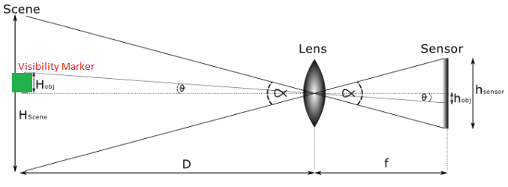

**Figure 6:** Pin hole camera approach

For the relative orientation angle (β), we use the ratio (r) of right edge height (reh) of the visibility marker to the left edge height (leh) of the visibility marker, r=reh/leh. If r=1, case 1, then β = 0. For r≠1 (case 2), orientation is anti-clockwise if r<1 and orientation is clockwise if for r>1. The values of ‘r’ are mapped onto another scale which is from -100 to +100, which is the scale for the angles defined for the control library of our robot’s. -100 being extreme anti-clockwise orientation, +100 being extreme clockwise orientation and 0 if orientation is zero. Figure 7 (left) shows the orientation angle.

For the relative direction angle (α) information, we use center of mass information of the visibility marker for both cases mentioned above. Also, we normalize the frame of camera such that the center of the frame is at origin. The idea is that the center of mass of the visibility marker should be at the origin of camera’s frame. So, the direction angle is more specifically defined as how much is the visibility marker (front robot) deviated from the origin in horizontal axis. Again, the horizontal axis (x-axis) information is mapped from -100 to +100 in similar way. -100 being the extreme left direction, +100 being the extreme right direction and 0 if at origin(α=0).Figure 7 (right) shows the direction angle.

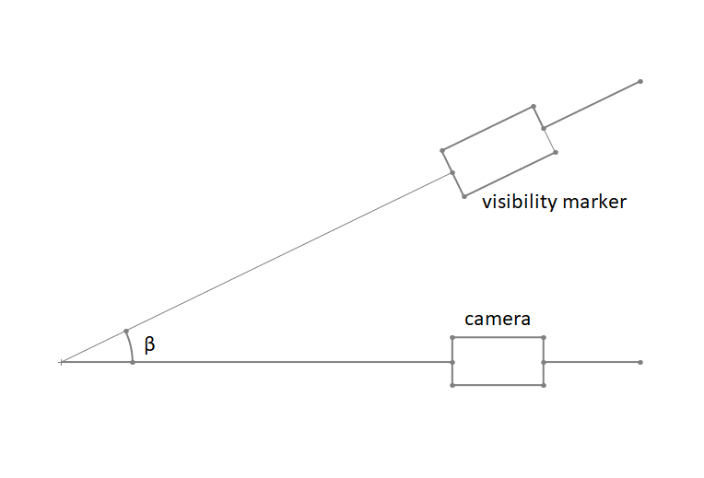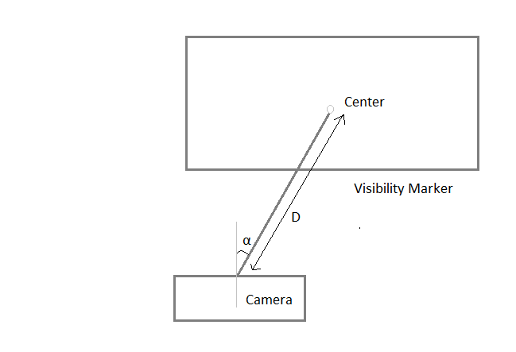

**Figure 7:** Orientation angle(left), Direction angle(right)

#### Leaving Signal

For the determination of leaving signal we use color detection, but this time within the visibility marker. By considering the area inside the visibility marker only, we ignore any other color outside the area. Then we use red color detection in a similar way with the green color detection for visibility marker. If red color is found that implies the front robot is giving leaving signal. Hence, the module gives the status of the leaving signal to the sensor library.

## All Control and Data Signals with Their Feedback Paths

The Slash on the data lines indicates that there are two channels of information.

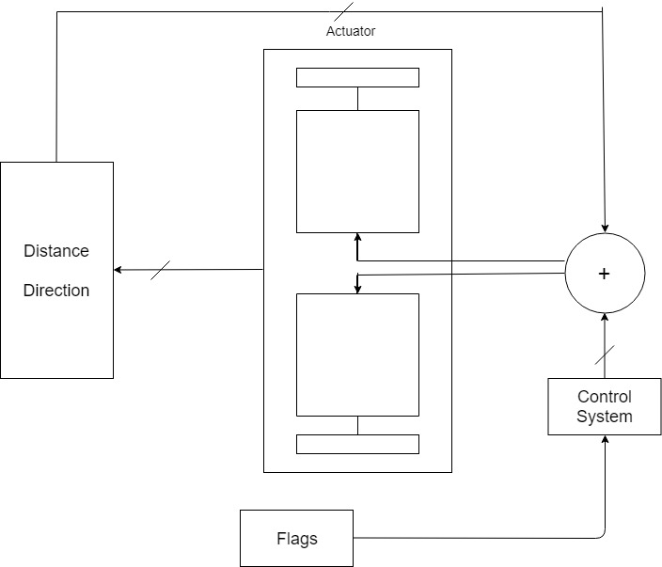

**Figure 8:** Control Data Path Overview

# Technical Specifications

## Overall System Specifications

* Maximum Speed: 46 cm/s
* Average power consumption:
* Height: 27 cm
* Length: 26 cm
* Width: 18 cm
* Weight: 2.9 kg

## Module Specifications

**Arduino Uno**

* Flash Memory: 32 KB
* SRAM: 2 KB
* EEPROM: 1 KB
* Clock Speed: 16 MHz
* Operating Voltage: 5 V
* 14 Digital I/O Pins (6 of them PWM Digital I/O Pins), 6 Analog Input Pins

**Raspberry Pi 3**

* CPU: 4× ARM Cortex-A53, 1.2GHz
* GPU: Broadcom VideoCore IV
* RAM: 1GB LPDDR2 (900 MHz)
* Networking: 10/100 Ethernet, 2.4GHz 802.11n wireless
* Bluetooth: Bluetooth 4.1 Classic, Bluetooth Low Energy
* Storage: microSD
* GPIO: 40-pin header, populated

**Ultrasonic Distance Sensor**

* Operating Voltage: 5 V DC
* Current: 15 mA
* Frequency: 40 Hz
* Distance measuring range: 2 to 400 cm

**Infrared Distance Sensor**

* Distance Measuring Range: 10 to 80 cm
* Type: Analog Output
* Supply Voltage: 4.5 to 5.5 V
* Current: 30 mA

**Infrared Direction Sensor**

* Distance Measurement Range: 10 to 80 cm
* Judgement Distance: 24 cm
* Supply Voltage -0.3 to 7 V

**Laser**

* Optical Power Output: 10 mW
* Light Output Wavelength: 670 nm

**Solar Panel**

* Nominal Voltage: 0.5 V
* Peak Current Current: 0.28 A
* Peak Power Production: 0.25 W

**Camera**

* Still Resolution: 5 Megapixels
* Sensor resolution: 2592 x 1944 pixels
* Sensor Image Area: 3.76 x 2.74 mm
* Pixel Size: 1.4 μm x 1.4 μm
* S/N Ratio: 36 dB
* Focal length: 3.60 mm +/- 0.01
* Horizontal Field of View: 53.50 +/- 0.13 degrees
* Vertical Field of View: 41.41 +/- 0.11 degrees

**XL4015 DC-DC Step-Down Converter**

* Voltage Regulating Mode: PWM
* Input Voltage: 8 to 36 V DC
* Output Voltage: 1.25 to 32 V DC
* Maximum Output Current: 5 A
* Output Power PMOS : 60 W
* Maximum Conversion Efficiency: 96 %
* Switching Frequency: 180 KHz

**Motors**

* Size: 25 D x 52L mm
* Weight: 88 g
* Shaft Diameter: 4 mm
* Gear Ratio: 46:85:1
* Free-run Speed at 12 V: 210 RPM
* Free-run Current at 12 V: 300 mA
* Stall Current at 12 V: 5600 mA
* Stall Torque at 12 V: 1.65 N-m

# Design Modifications

Some changes are made on both the design and the standards due to fulfill the requirements of the project.

## Design Changes

There are three major changes in the design. All of them are explained in detail below.

### Four-wheel and four motors drive system

For the movement of our robot, instead of using two wheels at the back and a free wheel in front of the robot, it is decided to use four-wheel differential drive with high torque motors. The reason behind is that on previous experiments, it is observed that movement of the robot is unpredictable because of the free wheel. After deciding about using four wheels, a research is made about hubs to connect the wheels. The research showed that these hubs are almost as expensive as motors; thus, connecting a motor to each wheel is a better decision regarding their contributions to driving mechanism and cost efficiency.

### Solar panel inside the box

In order to minimize the effects of the environment, it is decided to place the solar panels inside boxes. This provides the walls of the boxes to block most of the light that is created by the environment; thus, it becomes easier to have a distinction between the laser and other sources.

### Chassis

The previous chassis had only three wheels. Hence, a new chassis was required for four-wheel drive system. Therefore, we decided to design a new chassis ourselves to fulfill the requirements of the project and our subsystems. We set the dimensions of the chassis to maximum possible values in order to have more area for the components we are using. In addition, the chassis is specialized for the design choices we made. Moreover, we chose MDF as material of the chassis because it costs less compared to the alternatives and the weight, which is the biggest disadvantage of the material, does not create any problems since we are using four motors.

## Updated Standards

In order to make the solution easier, there are few changes on the standards that are decided previously.

### IR signal protocol change

IR signal protocol for leaving and last one signal is changed. Previously, two different frequencies were used to differentiate the signals. Now, there is only one of them.

Last on the line was a square wave of frequency 2 Khz.

Leaving the line flag was a square wave of 5Hz.

The new specifications of the proposed signals are as follows.

1. All signals use a carrier frequency of 38 Khz +- 20 percent.
2. The signals are no longer defined as frequency but as on and of times of the modulated signal.
   1. Leaving the line flag

\* on off time is 100ms +- 30 percent

\* on time between 100 - 500 ms

* 1. Last on the line flag

\* on off time is 200ms +- 30 percent

\* on time between 100 - 500 ms

### Number of Visibility Marker LED

Instead of using two LEDs as the secondary visibility marker, a single LED is to be used. The LED will be placed in the midpoint of the imaginary line joining the two LEDs that were previously defined in the standard.

The LED will have the following characteristics.

1. Power LED with consumption of 1 Watt..
2. Integrated lens with a radiation angle of 140 degrees.

### Restrictions placed on the rectangle

The thickness of the border surrounding the seven segment explicitly defined to be of 2.5 cm.

### Reasons for change in standards

#### IR signal protocol change

1. Carrier frequency has been added to make sure that the receiver does not falsely trigger when exposed to stray infrared radiation. Moreover, adding the carrier frequency has the added benefit of increasing the effective range as the noise observed by the receiver is reduced since the input signal can be filtered.
2. Some signal specifications have been relaxed. More specifically the on time of the signal has a much higher allowed tolerance. The added restrictions served no benefit and only limited the project companies in the implementation of their designs.
3. The Changed the frequency to a range that requires less cpu resources to detect and generate. One of the update frequency was too high and was deemed unnecessary The time between even changes has been increased which means that the cpu has to work less frequently.

#### Number of Visibility Marker LED

The visibility marker will be used the relative distance and direction between robots. Using a single LED makes the direction information relation with the relative angle close to linear. Removing one LED not only minimises the post processing required but also simplifies the requirements.

#### Restrictions placed on the rectangle

To provide compatibility between the robots, a thickness is set for the rectangle which is used as visibility marker.

# Compatibility Analysis of Sub-Blocks

## Sensor Signal Interfaces

### Distance and Direction Sensors

#### Raspberry Pi and Camera Distance and Direction

**I.Raspberry Pi and camera Signal Interface**

* CSI-2 Camera Interface

**II. Raspberry Pi and Arduino Signal Interface**

* UART Communication
* Baud Rate: 115200
* Data Protocol: 8 Bits no Parity

#### IR Distance and Direction Sensor Interface with Arduino

* Analog Signal Interface
* Connection with 2 analog pins of the arduino

### 

#### Standalone IR Direction Sensor

* Analog Signal Interface
* Connection with 1 analog pin of the arduino

#### Standalone Ultrasonic Distance Sensor

* Digital Interface
* Requires two pins one for trigger pin and another for echo.
* Two pins are connected with digital pin on the Arduino.
* Trigger pin is configured as the input pin of the Arduino.
* Echo pin is configured as the input pin on the arduino.

#### Solar Panel Laser Identification Sensors

**Interface of Solar Panel to the analog signal preprocessor**

The analog preprocessor takes the analog input of the solar panel and outputs the corresponding digital output.

Each one of the two solar panel laser detectors are connected to input of the analog preprocessor.

**Interface of preprocessor output to Arduino**

Preprocessor sets the output high on detection of laser and pulls the signal line low otherwise. Therefore the the signal can be sampled digitally from the microcontroller.

Each one of the two solar panel laser detectors preprocessors are connected to one pin of the arduino.

## Actuator Signal Interfaces

### Robot Motors

**PWM Signal Interface with motor drivers**

4 Channels to individually control speed of the motors

Connected to 4 PWM pins of the arduino

## Sensor Signal Interfaces Diagram

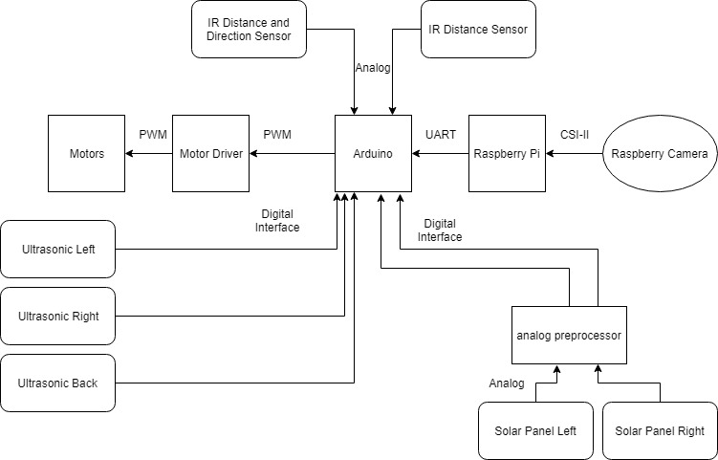

**Figure 9:** Signal Interface Diagram

# Compliance with Requirements

## Design Requirements

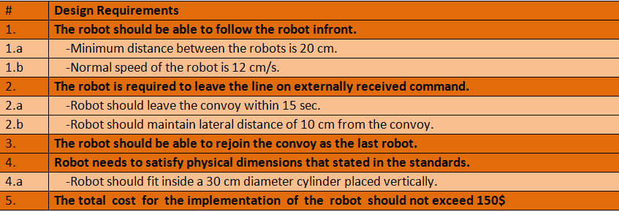

**Table 2:** Design Requirements

## Design Decisions According to the Requirements

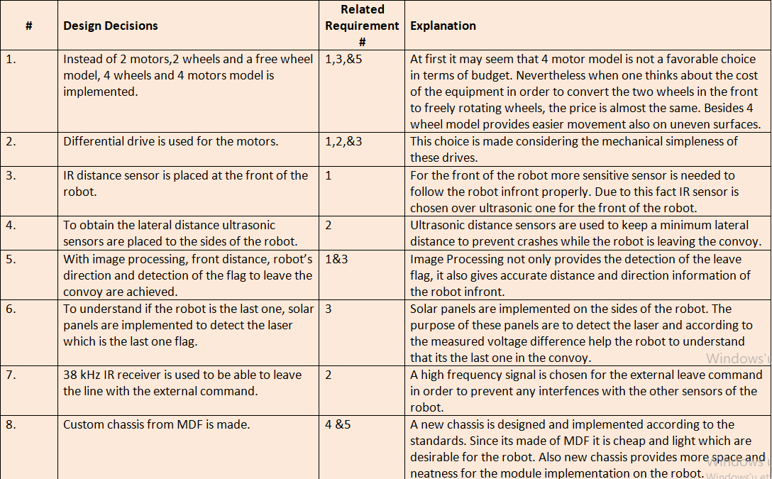

**Table 3:** Design Decisions according to Requirements

## Possible Error Sources

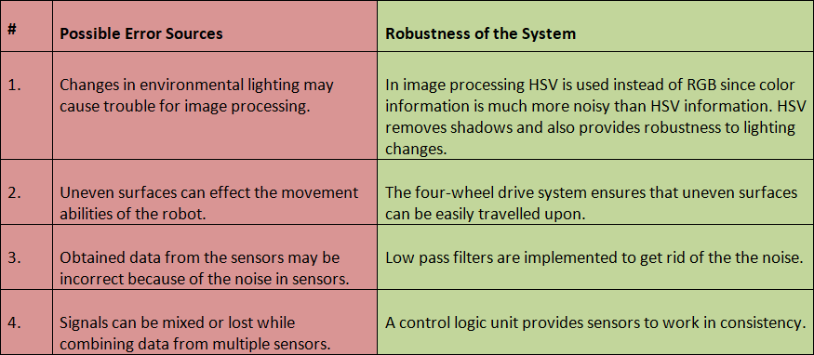

**Table 4:** Possible Error Sources and Robustness of the System

# Test Procedures and Assessments of Test Results

To claim that our robot is robust, we conducted some tests and verified its results. The results obtained were similar to the desired values. Also, the tests were conducted in different environments and measurement were taken several times.

## Image Processing

**Objective:** Visibility marker detection and leaving signal determination, reliable distance, direction angle and orientation angle measurement.

**Possible sources of errors:**

* Environmental light.

### Color Detection (red and green color)

**Test Procedure:**

* Different colored shapes are placed on a board.
* Different variations of green color are considered.
* Different variations of red are considered.
* Also, test in different environments (under different lighting conditions).

**Test Results:** Under progress

**Conclusion:** Only green color should be detected. Also range of green color that can be should be observed.

### Green Rectangle Detection

**Test Procedure:**

* Different green colored shapes are placed on a board**.**
* Rectangle shape is rotated about its axis and moved with respect to camera.

**Test Results:** Under progress

**Conclusion:** Only green rectangles or shapes similar to rectangle should be detected. Changing orientation of rectangle should not affect rectangles detection.

.

### Accuracy and precision of distance, direction and orientation.

**Test Procedure:**

* Distance
  + - Place the visibility marker (mock up) at 7 different positions.
    - Measure the actual distance using ruler.
    - Observe the distance output of image processing module.
    - Repeat the experiment 5 times.
* Direction angle
  + - Place the visibility marker (mock up) at 7 different angles from the robot.
    - Measure the relative direction angle physically.
    - Convert it to our scale(-100 to +100).
    - Observe the direction angle output of image processing module.
    - Repeat the experiment 5 times.
* Orientation angle:
  + - Rotate the visibility marker (mock up) clockwise or anti clockwise.
    - Measure the relative orientation angle physically.
    - Convert it to our scale(-100 to +100).
    - Measure the orientation angle output of image processing module.
    - Repeat the experiment 5 times.

**Test Results:** Under progress

**Conclusion:** Precise quantities will be observed.

## Distance Sensors

Two different types of distance sensors are used.

### IR Distance Sensor

**Objective:** Reliable distance measurement

**Possible sources of errors:**

* Stray IR Radiation

**Test Procedure:**

* IR distance sensor is placed.
* A wide blocking flat object is placed in front of the sensor.
* The object is placed at different distances from the sensors.
* The value read by the sensor is measured and tabulated.
* Experiment is repeated three times with different objects.

**Test Results:**

|  |  |  |  |
| --- | --- | --- | --- |
| **Actual Distance (cm)** | **Data for the first test (cm)** | **Data for the second test (cm)** | **Data for the third test (cm)** |
| **15** | 15.70 | 15.60 | 15.58 |
| **20** | 19.48 | 19.56 | 19.53 |
| **25** | 24.50 | 24.50 | 24.60 |
| **30** | 30.52 | 30.50 | 30.47 |
| **35** | 35.51 | 35.50 | 35.48 |
| **40** | 40.22 | 40.30 | 40.34 |
| **45** | 45.45 | 45.40 | 45.47 |
| **50** | 50.63 | 50.60 | 50.58 |
| **55** | 55.75 | 55.70 | 55.81 |
| **60** | 61.10 | 61.00 | 60.78 |

**Table 5:** IR Distance Sensor Test Results

**Conclusion:** Based on the requirements of the project, the collected data prove that the sensor provides satisfactory performance.

### Ultrasonic Distance Sensor

**Objective:** Reliable distance measurement

**Possible sources of errors:**

* Stray Sound Radiation

**Test Procedure:**

* The sensor is placed.
* A wide blocking flat object is placed in front of the sensor.
* The object is placed at different distances from the sensors.
* The value read by the sensor is measured and tabulated.
* Experiment is repeated three times with different objects.

**Test Results:**

|  |  |  |  |
| --- | --- | --- | --- |
| **Actual Distance (cm)** | **Data for the first test (cm)** | **Data for the second test (cm)** | **Data for the second test (cm)** |
| **15** | 16 | 15 | 16 |
| **16** | 17 | 16 | 17 |
| **17** | 18 | 17 | 18 |
| **18** | 19 | 18 | 19 |
| **19** | 20 | 19 | 20 |
| **20** | 21 | 20 | 21 |
| **21** | 22 | 21 | 22 |
| **22** | 23 | 22 | 23 |
| **23** | 24 | 23 | 24 |
| **24** | 25 | 24 | 25 |
| **25** | 26 | 25 | 26 |
| **26** | 27 | 26 | 27 |
| **27** | 28 | 27 | 28 |
| **28** | 29 | 28 | 29 |
| **29** | 30 | 29 | 30 |
| **30** | 31 | 30 | 31 |
| **35** | 36 | 35 | 36 |
| **40** | 41 | 40 | 41 |
| **45** | 46 | 45 | 46 |
| **50** | 51 | 50 | 51 |
| **55** | 56 | 55 | 56 |
| **60** | 61 | 60 | 61 |

**Table 6:** Ultrasonic distance sensor test results

**Conclusion:** Based on the requirements of the project, the collected data prove that the sensor provides satisfactory performance.

## Solar Panel

**Objective:** To detect the last robot

**Possible sources of errors:**

* Light from environment

**Test Procedure:**

* Solar panel is connected to a multimeter.
* Different types of light are applied to the solar panel.
* Voltage between the terminals of the panel is measured.

**Test Results:**

|  |  |  |
| --- | --- | --- |
| **Light source** | **Voltage from 10 cm (V)** | **Voltage from 20 cm (V)** |
| **Torch** | 0.28 | 0.11 |
| **Flashlight of a phone camera** | 0.40 | 0.24 |
| **Laser** | 0.60 | 0.60 |

**Table 7:** Solar Panel Test Results

**Conclusion:** It is true that the environmental light may affect the solar panel; however, regarding the magnitude of the voltage created by the laser, by having a threshold value and comparing it with the voltage of the solar panel, it is possible to use the component to fulfill the desired task.

## Robot Speed

**Objective:** To fulfill the minimum speed requirement, which is 12 cm/s, and to manage to have sufficient speed to catch other robots if it leaves the line.

**Possible sources of errors:**

* Weight
* Uneven surface
* Surface type

**Test Procedure:**

* Robot is placed on different surfaces and switched on.
* The speed is measured.
* A load is added to increase the total weight.
* Again, the robot is placed on different surfaces and switched on.
* The speed is measured

**Test Results:**

|  |  |  |
| --- | --- | --- |
| **Surface type** | **Speed without additional weight (cm/s)** | **Speed with additional load (cm/s)** |
| **Marble** | 39 | 45 |
| **Wood** | 40 | 46 |

**Table 8:** Speed Test Results

**Conclusion:** The results show that the speed of the robot can meet the requirements. It is also sufficient to catch the leading robots if it leaves from the convoy.

## Turning

**Objective:** To satisfy the minimum radius of the route of the convoy and also sharper turns to make necessary maneuvers.

**Possible sources of errors:**

* Motors
* Wheels
* Uneven surfaces

**Test Procedure:**

* A code a for pre-programmed route consists of turns with different radiuses for both towards left and right is uploaded to the microcontroller.
* The robot is placed on the ground and switched on.
* The maneuvers the robot makes are observed.
* The tests were repeated on the various test surfaces.

**Test Results:**

|  |  |
| --- | --- |
| **Surface type** | **Maintained 100 cm turning radius** |
| **Marble** | Successful |
| **Wood** | Successful |
| **Uneven Surface** | Successful |

**Table 9:** Turning Test Results

**Conclusion:** The robot is capable to perform both sharp and wide turns for both towards left and towards right. The controller library, wheels and motors can perform required maneuvers.

## Leaving

**Objective:** To make the robot perform the maneuver as soon as possible after giving the command.

**Possible sources of errors:**

* Ambient noise

**Test Procedure:**

* The robot is placed on the ground and switched on.
* A signal is transmitted to the robot by an IR remote control.
* The test was also conducted with infrared output of a remote in pointed towards the receiver.

**Test Results:**

|  |  |
| --- | --- |
| **Surface type** | **Response Time** |
| **No Noise** | <1s |
| **IR remote Noise** | <1s |

**Table 10:** Leaving Test Results

**Conclusion:**  The time is measured by a stopwatch. Therefore, the results could only be made accurate to the nearest 10th of the second considering the human reaction time. However, it is observed that the response time is less than 1 second which satisfies the requirements.

## Following

**Possible sources of errors:**

* Not having a radial emission from the IR LED
* Not able to detect the IR light by the sensor located at the far edge

**Test Procedure:**

* Two IR sensors are located on different sides of a rectangle protoboard symmetrically.
* Data are recorded from different distances and angles.
* The robot is placed on the ground and switched on.
* The mock up with IR actuator is moved in front of the robot and its response is observed.

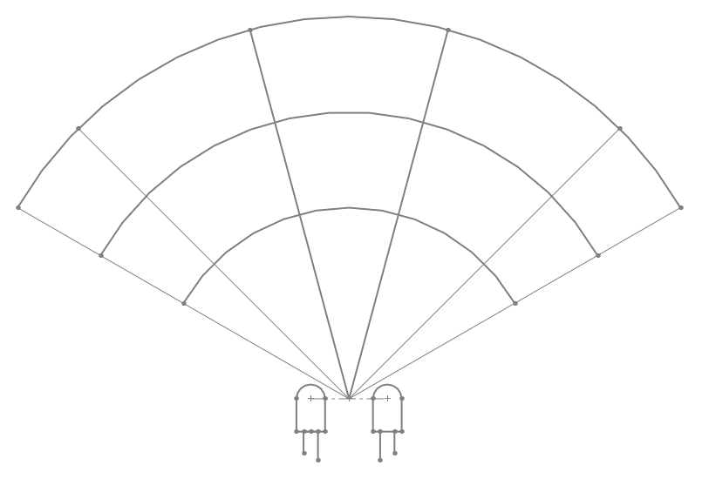

**Figure 10:** Test Procedure for the Direction Sensor

**Test Results:** Data read by sensors are symmetric. The robot can follow the leading robot. More quantitative tests shall be performed once the controller subsystem more closely resembles its final form.

**Conclusion:** The proposed method for detecting the robot in front fulfills the requirements. By processing data, it is observed that the task is performed.

## Power Delivery

**Objective:** To be able to supply the required power to the robot for at least 5 minutes.

**Possible sources of errors:**

* Ambient Temperature of the room
* Activity of the mockup robot

**Test Procedure:**

* The robot it let to follow the mockup robot.
* The battery percentage is calculated after 5 minutes of activity.
* Test was repeated for different activity levels of the robot.

**Test Results:**

|  |  |
| --- | --- |
| **Surface type** | **Battery Percentage after Test** |
| **High Activity** | 40 % |
| **Low Activity** | 50 % |

**Table 11:** Power Test Results

**Conclusion** The power delivery system has proved itself capable to provide the required amount of energy for the demonstration.

# Resource Management

All of the resources are explained in detail.

## Budget Analysis

The budget analysis can be seen in Table 12.

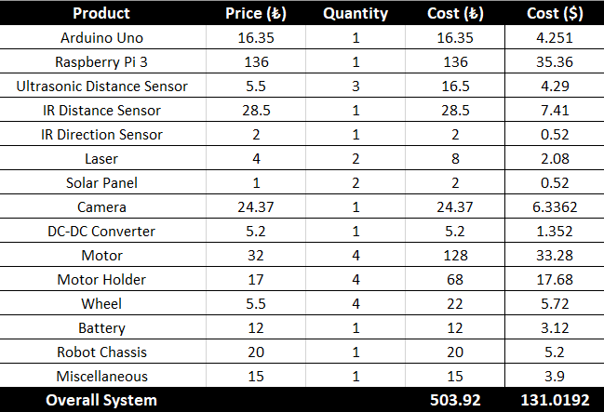

**Table 12:** Budget Analysis for the Project

Arduino Uno has a very low price. Therefore, it was not required to look for alternatives. Raspberry Pi 3 is the cheapest one that fulfills the requirements for image processing. For camera, after making an online search, a very good offer for Raspberry Pi camera was found. Other components such as motors, sensor or actuars are the cheapest ones that meet the requirement of the needs of the project

## Power Distribution and Management

The power is distributed over two voltage levels. The battery is of 12 Volts and is connected to main power hungry components such as the motors. The power is stepped down using a high efficiency DC-DC Step down power converter and power is supplied to rest of the components that require 5 volts such as the raspberry pi and arduino. All of the sensors take power directly from the arduino since arduino provides sufficient current to power those components.

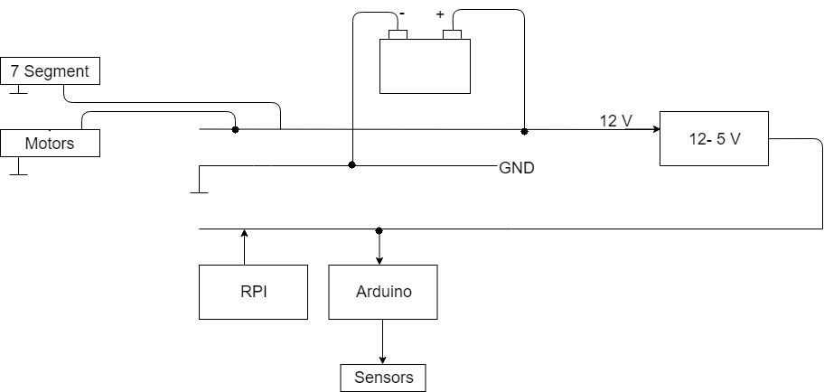

**Figure 11:** Power Flow Diagram of the Overall System

## CPU Resource management

The most time sensitive part of the program, which is written for the microcontroller, is feedback controller. In order to have a decent performance, the loop is needed to be run at at least 50 Hz, which means that the single loop should finished at 0.02 seconds. This is achieved by using non-blocking calls so that the CPU is not held hostage by any subroutine. From the initial testing, it is verified that the program needs to fulfill the desired requirement.

## Memory

For minimizing data requirement, appropriate data types are used so the program did not consume any useless memory. In addition to this, the variables which are not required to be global are defined inside the functions. This provides these variables to vanish after the functions are executed; thus, the memory is freed up for different functions.

## Gantt Chart

The schedule of the OJO can be seen in the Figure 12.  
   
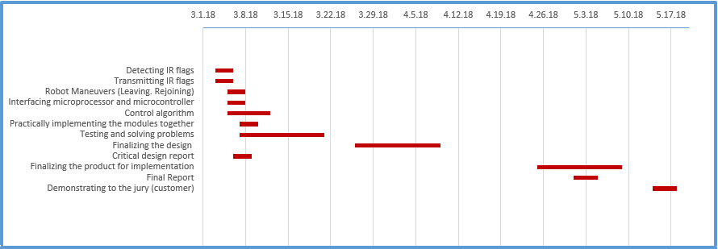

**Figure 12**: Gantt Chart for the Rest of the Semester

# Conclusion

This document contained the description of overall system and the subsystems. In the description, the data signals were described in detail. The technical specification and the compatibility of the systems were also discussed. In this document, the test plans (some of them to be conducted) and their results are also discussed. We also gave analysis on our resource management, such as, power analysis of the system and cost analysis of the project.

We are confident that our robot’s design, which is supported by various test results, is consistent with the customer requirements. We also assure that we will be able to successfully complete and implement our project before the deadline.

# 

# 

# 

# Appendix

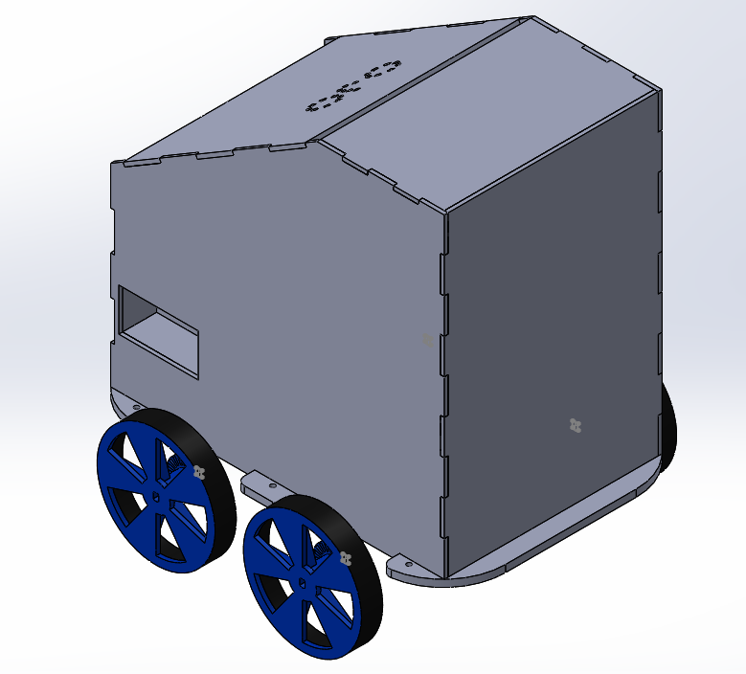

**Figure A1:** 3D model of the robot



**Figure A2:** 3D model of the robot